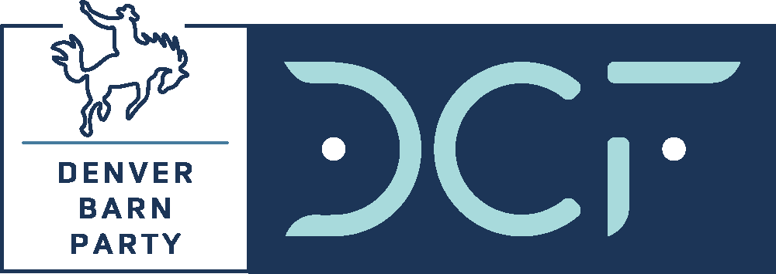
SPONSORSHIP AGREEMENT
Denver Barn Party @ Levitt Pavilion
September 30, 2023
AEG Presents DUSTIN LYNCH

Sponsor Company Name: Click or tap here to enter text.
Sponsor Contact Name: Click or tap here to enter text.
Address: Click or tap here to enter text.
Click or tap here to enter text.
Phone: Click or tap here to enter text.
Email: Click or tap here to enter text.

DCF Representative: Click or tap here to enter text.

Standard Sponsorships:

☐ $15,000 Pre-Show Tailgate Sponsor
VIP taillgate area signage, Gold Buckle (10 VIP Reserved) + 10 VIP GA tickets, headliner meet-and-greet, social media
☐ $12,500 Stage or Bar Sponsor
Signage, Silver Buckle (8 VIP Reserved) + 10 VIP GA tickets, headliner meet-and-greet, social media
☐ VIP Table Sponsorships*
☐ Gold (10 VIP Reserved Tickets): $6,000
☐ Silver (8 VIP Reserved Tickets): $4,500
☐ Bronze (6 VIP Reserved Tickets): $3,000
☐ Boot Stomp (4 VIP Reserved Tickets): $2,000

*EARKY BIRD discount until August 15 ($500 for Gold and Silver). Sponsorships include pre-show Tailgate, reserved table in VIP-only restricted access area, hosted VIP-only bar and complimentary Tailgate food, VIP event entrance.

Describe any Modifications to standard pricing or deliverables:
Insert modifications here. Modifications from the standard sponsorship above must be approved by Event Chair Matt Conway (matt@denverluxuryproperties.com) or Sales Chair Michael Ervolina (michael@ervosquare.com).

Click or tap here to enter text.
Sponsor Signature:______________________________ Date:____________________

Payment Method:
☐ Check (Payable to Denver Children’s Foundation; PO Box 202684, Denver CO 80220-8684)
☐ Credit card or ACH (contact me)
☐ Please send me an invoice

DCF Authorization Signature:______________________________ Date:____________________
Authorization allowed by Event/Sales Chairs or Executive Director

