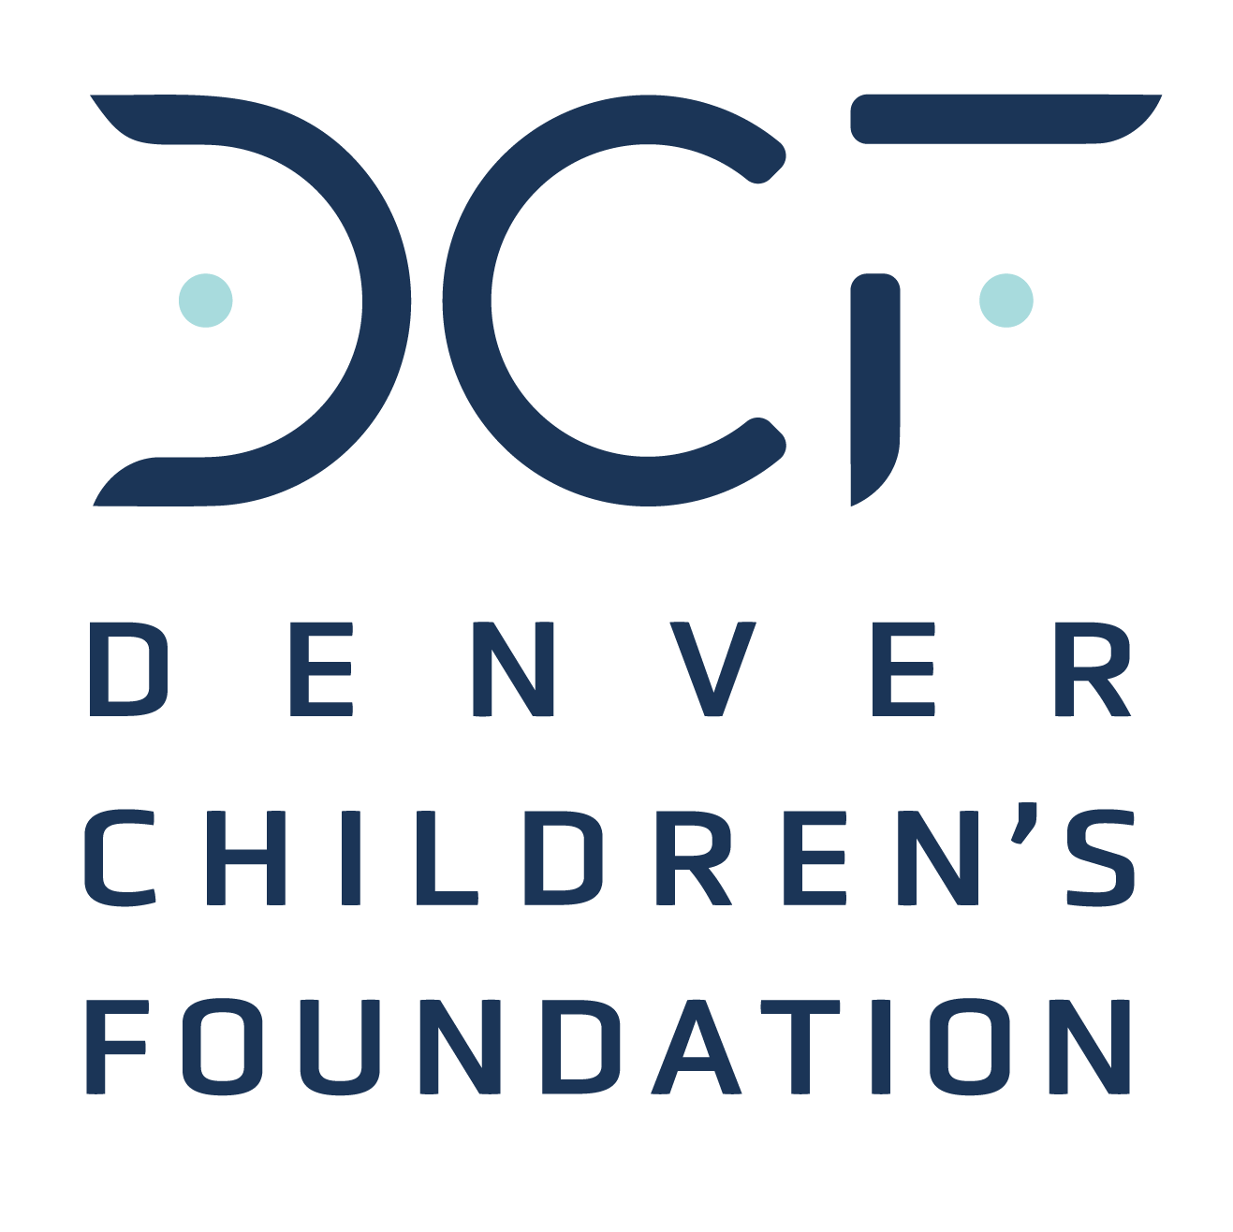
SPONSORSHIP AGREEMENT
Leaders Fore Kids Golf Classic
The Club at Ravenna, June 3, 2024

Sponsor Company Name: Click or tap here to enter text.
Sponsor Contact Name: Click or tap here to enter text.
Address: Click or tap here to enter text.
Click or tap here to enter text.
Phone: Click or tap here to enter text.
Email: Click or tap here to enter text. Website: Click or tap here to enter text.

DCF Representative: Click or tap here to enter text.

Standard Sponsorships:

☐ $25,000 Major Title Sponsorship
2x Foursomes, co-branded golf polo, signage/ads, balls with sponsor logo.
☐ Food & Beverage Sponsorships
Includes event signage, website logo, and event speaking opportunity.
Bar Cart & Refreshment Station ($5,000), Awards Banquet ($4,000), Breakfast ($3,000), and/or Lunch ($3,000). Add $5,000 for an Elite Foursome.
☐ Experience Sponsorships
Includes event signage, website logo, and on-course hosting opportunity.
Golf Cart sponsor ($10,000), Long-drive sponsor ($4,000), Wager Game sponsor ($3,000), or Closest-to-Pin sponsor ($2,000). Add $5,000 for an Elite Foursome.
*Early Bird discount of $500 through April 1.

☐ $5,000 Elite Foursome*
1x Foursome, hole signage. Select Add-ons:
☐ 2 Mulligans ($50)
☐ Pro Drive for 4 Players ($200)
☐ Closest-to-Pin Entry for 4 Players ($200)
☐ Wager Game Entry for 4 Players ($200)
☐ Promotional Item Sponsorships
YOUR logo on items! Opportunities: Quarter-zip co-branded golf pullover ($12,000), co-branded player hat ($7,500), drink koozie ($5,000), golf towel ($4,000), divot tool ($3,000), pin flag ($3,000), sunscreen ($2,000), or suggest your item (price may vary). Add $5,000 for an Elite Foursome.
☐ Golf + Polo Classic Combo
Discounted Elite Foursome + Polo Classic table (10 tix/day) July 12-14 at Littleton Polo Reserve
☐ Golf+VIP Weekend Polo combo deal – $15,500
☐ Golf+Regular Weekend Polo combo deal – $12,500

Describe any Modifications to standard pricing or deliverables:
Insert modifications here. Modifications from the standard sponsorship above must be approved by Event Chair, Nick Neintimp, nick.neintimp@gmail.com.

Click or tap here to enter text.

Sponsor Signature: ________________________________ Date: ___________________
Payment Method:
☐ Check (Payable to Denver Children’s Foundation; PO Box 202684, Denver CO 80220-8684)
☐ Credit card (contact me)
☐ Please send me an invoice

DCF Authorization Signature:______________________________ Date: ____________________
Authorization allowed by Event/Sales Chair or Executive Director

